Docker Basic Commands 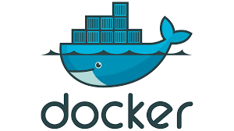

docker-compose: used for configuring and starting multiple Docker containers on the same host–so you don't have to start each container separately.
docker-compose scale <service name> = <no of instances>: sets the number of containers to run for a service
docker-compose ps: lists all the running containers
docker-compose down: shuts down all the running containers
docker-compose logs: used to get all the logs related to the container
docker pull: pulls an image from docker hub
docker push: pushes an image to the docker hub repo.
docker start: starts the container
docker stop: stops the container
docker rm: removes/delete the container

